No. | Answer
a i [H₃O⁺] = 1.0 mol L⁻¹ = 1 x 10⁰ mol L⁻¹
pH = –log₁₀[H₃O⁺] = –log₁₀ (1 x 10⁰) = 0
ii As HCl is a strong, monoprotic acid:
[H₃O⁺] = [HCl] = 9.05 × 10^{–8} mol L⁻¹
pH = –log₁₀[H₃O⁺] = –log₁₀(9.05 × 10^{–8}) = 7.04
Of course this answer does not make sense as a solution of an acid cannot have a pH > 7 at 25°C. In this situation, the self-ionisation of water already produces a solution with a pH of 7, so a solution that contains this small amount of additional HCl would have a pH slightly below 7.
b i [OH–] = 0.0700 mol L⁻¹
K_{w} = [H₃O⁺][OH–] = 1 x 10^{–14}
∴ [H₃O⁺] = 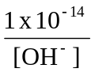 = 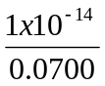 = 1.43 × 10^{–13} mol L⁻¹
pH = –log₁₀[H₃O⁺] = –log₁₀(1.43 × 10^{–13}) = 12.8
ii [NaOH] = [OH–] = 4.00 × 10^{–12} mol L⁻¹
K_{w} = [H₃O⁺][OH–] = 1 x 10^{–14}
∴ [H₃O⁺] = = 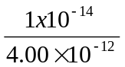 = 2.50 × 10^{–3} mol L⁻¹
pH = –log₁₀[H₃O⁺] = –log₁₀(2.50 × 10^{–3}) = 2.60
iii [OH–] = 2 × [Ba(OH)₂] = 0.0124 mol L⁻¹
K_{w} = [H₃O⁺][OH–] = 1 x 10^{–14}
∴ [H₃O⁺] = 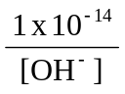 = 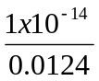 = 8.06 × 10^{–13} mol L⁻¹
pH = –log₁₀[H₃O⁺] = –log₁₀(8.06 × 10^{–13}) = 12.1
c i [H₃O⁺] = 10^{–pH} = 10^{–1.07} = 0.085 mol L⁻¹
ii [H₃O⁺] = 10^{–pH} = 10^{–14.7} = 2.0 × 10^{–15} mol L⁻¹
c₁ × V₁ = c₂ × V₂
∴3.55 × 45.0 = c₂ × 295
∴ c₂ = 0.542 mol L⁻¹
As HNO₃ is a strong, monoprotic acid:
[H₃O⁺] = [HNO₃] = 0.542 mol L⁻¹
pH = –log₁₀[H₃O⁺] = –log₁₀0.542 = 0.266
n(NaOH) = 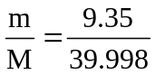 = 0.234 mol
[NaOH] = 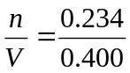 = 0.584 mol L⁻¹
[OH–] = [NaOH] = 0.584 mol L⁻¹
K_{w} = [H₃O⁺][OH–] = 1 x 10^{–14}
∴ [H₃O⁺] = = 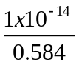 = 1.71 × 10^{–14} mol L⁻¹
pH = –log₁₀[H₃O⁺] = –log₁₀(1.71 × 10^{–14}) = 13.8
K_{st} = [Ag⁺][OH–] = 2.0 × 10^{–8}
From the equation, [Ag⁺] = [OH–]
∴ [OH–] = 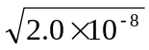 = 1.41 × 10^{–4} mol L⁻¹
K_{w} = [H₃O⁺][OH–] = 1 x 10^{–14}
∴ [H₃O⁺] = = 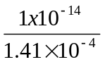 = 7.07 × 10^{–11} mol L⁻¹
pH = –log₁₀[H₃O⁺] = –log₁₀(7.07 × 10^{–11}) = 10.2
a C₆H₅OH(aq) + H₂O(l) ⇌ C₆H₅O–(aq) + H₃O⁺(aq)
∴ K_{a} = 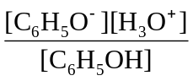
b HN₃(aq) + H₂O(l) ⇌ N₃–(aq) + H₃O⁺(aq)
∴ K_{a} = 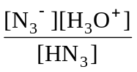
c HPO₃^{2–}(aq) + H₂O(l) ⇌ PO₃^{3–}(aq) + H₃O⁺(aq)
∴ K_{a} = 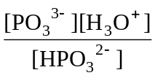
a K_{a1} = 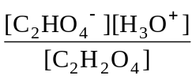
K_{a2} = 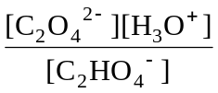
b K_{a1} > K_{a2}
K_{a} = 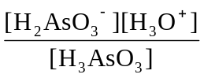 = 5.13 × 10^{–10}
From the equation, [H₂AsO₃–] = [H₃O⁺] at equilibrium, and also, for a weak acid,
[H₃AsO₃]_{i} ≅ [H₃AsO₃]_{eq} = 0.882 mol L⁻¹
∴ = 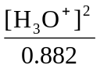 = 5.13 × 10^{–10}
∴ [H₃O⁺] = 2.13 × 10^{–5} mol L⁻¹
pH = –log₁₀[H₃O⁺] = –log₁₀ (2.13 × 10^{–5}) = 4.67
K_{a} = 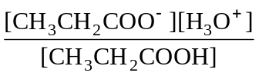
[H₃O⁺] = 10^{–pH} = 10^{–2.80} = 0.00158 mol L⁻¹
From the equation, [CH₃CH₂COO–]_{eq} = [H₃O⁺]_{eq} = 0.00158 mol L⁻¹ and also, for a weak acid, [CH₃CH₂COOH]_{i} ≅ [CH₃CH₂COOH]_{eq} = 0.184 mol L⁻¹
∴ K_{a} = = 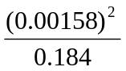 = 1.37 × 10^{–5}
% hydrolysis = 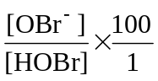 = 0.00828%
For a weak acid: [HOBr]_{i} ≅ [HOBr]_{eq} = 0.350 mol L⁻¹
∴ 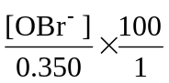 = 0.00828 ∴ [OBr–] = 2.90 × 10^{–5} mol L⁻¹
From the equation:
[OBr–]_{eq} = [H₃O⁺]_{eq} = 2.90 × 10^{–5} mol L⁻¹
pH = –log₁₀[H₃O⁺] = –log₁₀(2.90 × 10^{–5}) = 4.54
K_{a} = 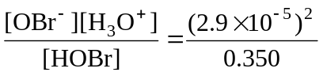 = 2.40 × 10^{–9}
a K_{a} = 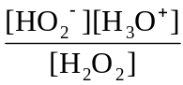 = 2.27 × 10^{–12}
b [H₃O⁺] = 10^{–pH} = 1 x 10^{–6}
From the equation, [HO₂–]_{eq} = [H₃O⁺]_{eq}
and also, for a weak acid,
[H₂O₂]_{i} ≅ [H₂O₂]_{eq} = 0.44 mol L⁻¹
% ionisation = 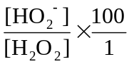 = 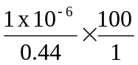 = 2.3 × 10^{–4}

